**Topic**

Social media communication on chemical ecology

**Location**

Room L 125, Czech University of Life Science Prague (Faculty of Forestry and Wood Sciences) in Prague, Czech Republic:

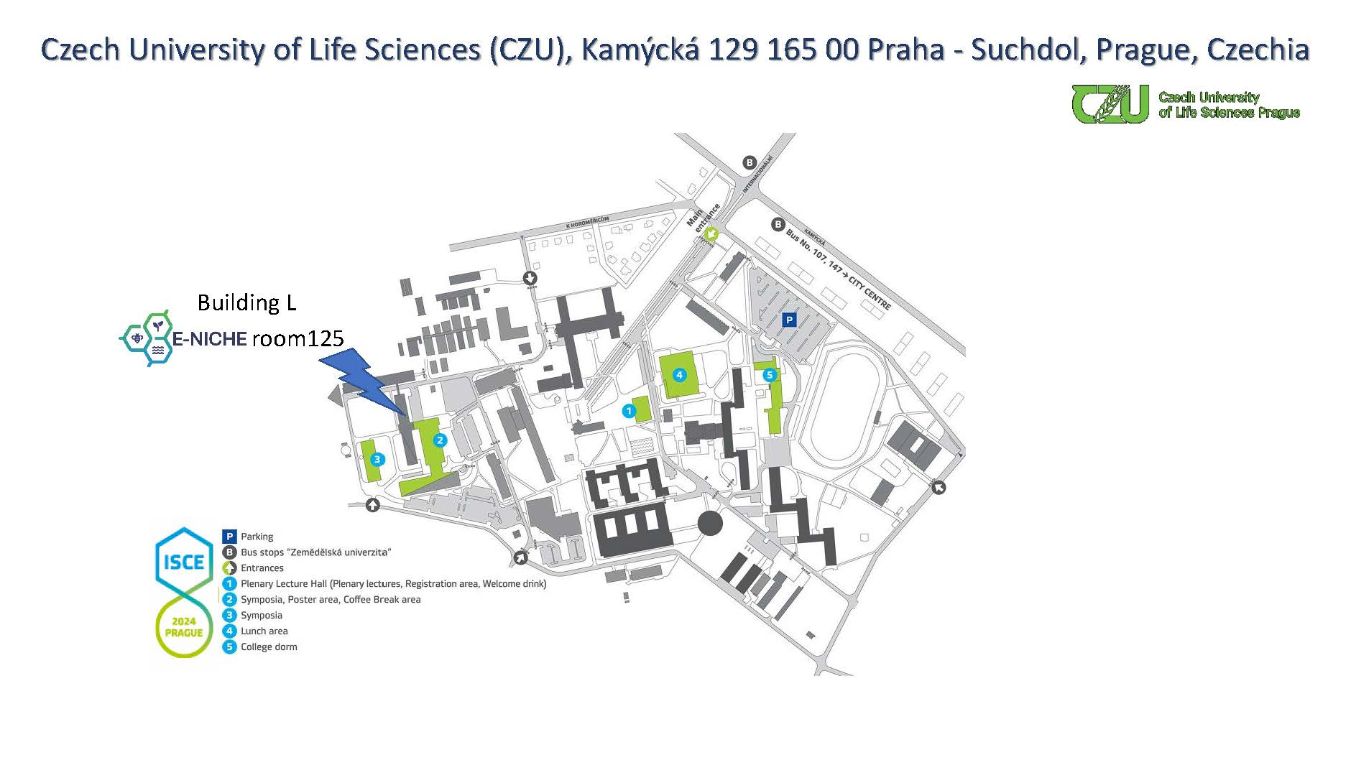

**Schedule\***

12:00 - 13:00 | Welcome reception

13:00 - 14:30 | plenary session (**hybrid**) featuring contributions from:

* Julie Louis, Science Communication manager of the University of Liège
* Prof. Dr. Christelle A. M. Robert, Head of the Chemical Ecology group at the Institute of Plant Science, University of Bern

14:30 - 15:00 | coffee break

15:00 - 17:00 | communication activities in groups (**on site only**):

* Youtube video capsule: record a short clip in a standardized format on your research to be featured on the E-NICHE Youtube channel that will be launched shortly after the workshop
* European Chemical Ecology community building brainstorm
* E-NICHE social media hackathon

*In case one of the plenary speakers runs late, we might move the coffee break forward and continue part of the plenary program after the coffee break.